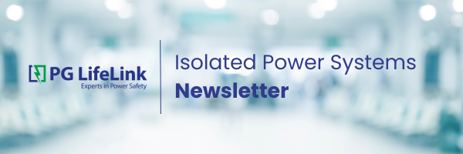

Welcome to the second edition of our newsletter! Here, we share our reps' sales strategies and best practices. This month, we're highlighting RW Chapman & Co., who has represented PG LifeLink since 2010 in Virginia (except Metro Washington DC), North Carolina, and South Carolina.

At Chapman, success is not just about selling products; it's about building lasting relationships and taking ownership of every customer interaction. As an employee-owned (ESOP) company with about 50 employees, this structure creates stability, fosters commitment, and ensures that every team member has a personal investment in the company's long-term growth. Founded in 1959 on independence, accountability, and deep market expertise, Chapman has become a trusted partner for Isolated Power Systems in their markets.

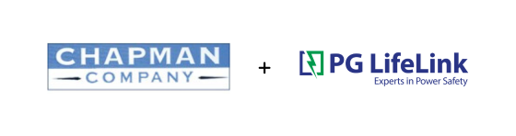
Since 2010, Chapman Company has served as a PG LifeLink manufacturer representative for North Carolina, South Carolina, and Virginia. These states have historically used Schneider Electric for isolated power, and we have had limited success in the past. Major Health systems such as Duke Health or the University of North Carolina would default to Schneider no matter how many projects we quoted. Since their appointment, they have diligently built up the presence of PG LifeLink and increased our sales success. It took years of patience and effort. By 2019, the market had turned around, and in 2023, they were PG LifeLink's leading rep and booking the largest order in company history at that time. With the departure of Schneider, the company is now positioned to dominate its markets.

So, what is the secret to their success? For Chapman, it comes down to a simple yet powerful philosophy: treating customers' pain points as if they were their own.

  "How can I make your job easier?" is a question Andy Ebert frequently asks his distributors. He explains that taking ownership of a customer's pain points differentiates him from the competition, allowing him to genuinely influence people to make informed buying decisions.
  This commitment enables Chapman to transcend traditional sales relationships, influencing buying decisions not just based on price but also on long-term value. Through consistent effort and strategic use of facility visits, they slowly broke the SQD hold on the market.
  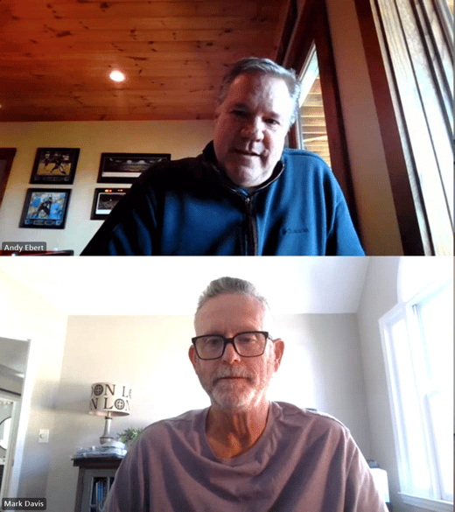
  Mark Davis and Andy Ebert: R.W Chapman & Co.

Where many reps might have decided the line was not worth the effort, Chapman never gave up. "We think long-term and do not focus solely on the projects at hand; rather, we prioritize keeping our customers happy over the long term," Mike Doggett explains. He describes his work as an extension of the hospital facility, making it easy for end users, consulting engineers, and contractors to reach out for support when needed.

Chapman has also found success through its retrofit and service business, which has led to new isolated power panel sales. In addition to the typical contractor, distributor, and engineer relationships, Chapman has focused on developing relationships at the facility level. This has resulted in large retrofit opportunities that typically result in sales and commissioning dollars quickly. This proactive approach has established a successful entry point into the facilities for new panel sales in future construction projects.

A Partnership Built on Collaboration
One key to Chapman's ongoing success is the strength of its partnerships with suppliers, especially with PG LifeLink. "PG LifeLink is one of the easiest companies we deal with day-to-day from a quotation standpoint," says Mark Davis. "They are also one of our most profitable suppliers in terms of time investment and market recognition."

This alignment between Chapman and PG LifeLink fosters a collaborative, solution-driven approach focused on achieving the best outcomes for the end user. Chapman shared that they've been able to rely on Scott Mustian for strategic customer visits at least once a year, which helps build customer confidence in PG LifeLink and Chapman. By combining deep customer knowledge with high-quality products and strong relationships, Chapman ensures that customers receive more than just products—they receive expertise, strategic guidance, and long-term value.

Advice for Success in the Industry
Chapman emphasizes the importance of building trust and staying proactive, providing this insight for the industry: "You have to get in front of the customer to experience what they are experiencing," Andy Ebert says. Chapman's hands-on and autonomous sales culture puts them in a unique position to represent PG LifeLink's product lines. They view their outside sales team as "an owner of their assigned territory." Long-term tenure in these markets ensures long-term, consistent success.

Beyond project-specific sales strategies, success in this industry relies on the fundamentals—blocking and tackling business. As Mark Davis puts it, Chapman is well-positioned in the market and has a strong, focused understanding of it. Consistent follow-up with the right people who influence buying decisions in a specific area is essential. "It's the trifecta," Mark says, "Consultants, end user calls, and constant follow-up marketing and discussions."

If you want to discuss any of the strategies mentioned with Andy, Mark, or Mike, they are open to conversations and can be reached at aebert@rwchapman.com, mdavis@rwchapman.com, and mdoggett@rwchapman.com.

Welcome PG LifeLink's New President

  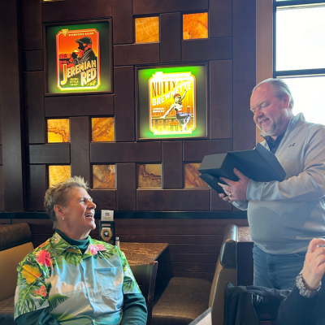
  Joe Tanner and Judy Kathman at Judy's retierment party
  We're thrilled to share that Joe Tanner has stepped into the role of President at PG LifeLink. A dedicated leader with 18 years at our company, Joe has been instrumental in driving growth, fostering strong relationships, and upholding our commitment to quality and service. His deep understanding of our business and industry makes him the perfect fit to lead us into the next chapter.
Joe has a wealth of experience within the company, having served as Vice President of Finance and Operations at both PG LifeLink and Post Glover Resistors. As he takes on this new role, he focuses on strengthening our relationships, expanding opportunities, and ensuring that PG LifeLink remains a trusted partner for you.

Please join us in congratulating Joe Tanner on this well-earned leadership role. We're excited for the future under his guidance and look forward to continuing our success together!

Celebrating Recent Major Project Wins!

St. Lukes Boise Med Center (Idaho)
Project Panel Count: 66 Isolated Power Panels
Representative: Nexus Power Sales & Solutions

St. Luke's Hospital Anderson (Pennsylvania)
Project Panel Count: 70 Isolated Power Panels
Representative: Ewing Two

Adventura Hospital (Florida)
Project Panel Count: 22 Isolated Power Panels
Representative: EMR Associates (bought in Tennessee)

Columbia Memorial Hospital (Oregon)
Project Panel Count: 24 Isolated Power Panels
Representative: Nexus Power Sales & Solutions

Schneider Electric/SQD Exit Insights

Here is what we've been hearing from our reps who have found success securing business:
- Assure customers that PG LifeLink's primary focus is Isolated Power and that you will work closely to ensure the project runs smoothly from quoting to submittals to delivery and commissioning.
- Referrals to Bender should not be a barrier, as engineering firms are reconsidering their specs and contacting alternative suppliers.
- Distributors have shared a previous dissatisfaction with Bender/Square D panels and responsiveness with support.

Questions to consider:
- Have you connected with EVERY electrical engineer in your territory who designs for medical construction? You can be sure Bender will.
- Have you developed a relationship with distributors carrying Schneider Electric gear? We continue to hear of distributors and contractors who have not been happy with a previous Bender/SQDE experience. Take advantage of that and share what you and PG LifeLink can do.
We're here to support you with the tools you need to make the most of this moment!

Project Watch List

Explore the list of projects on our watch list below.

Children's Hospital of Philadelphia
Project Panel Count: 80 Isolated Power Panels
Representative: Ewing Two

Henry Ford Hospital Detroit
Project Panel Count: 164 Isolated Power Panels
Representative: TEPS

Harris Health LBJ Hospital Expansion (Texas)
Project Panel Count: 129 Isolated Power Panels
Representative: Peterson Scharack & Associates

UK Healthcare Chandler Hospital Expansion (Kentucky)
Project Panel Count: 123 Isolated Power Panels
Representative: CM Buck & Associates

Sales & Marketing

Plug and play marketing material to add value, drive projects down the funnel, and educate the end user.

1. PG LifeLink Isolated Power Flyer: An informational flyer to address the industry changes and position PG LifeLink as a leader in the isolated power market.
2. Isolated Power System Design & Installation Guidelines: A document with guidance for designers, specifiers, installers, and users of Isolated Power Systems.
3. Plus Series Product Overview: Explore the latest Plus Series Line of Isolated Power System products and Additional Options.





PG LifeLink, 167 Gap Way, Erlanger, KY 41018, www.pglifelink.com, (800) 287-4123
Unsubscribe Manage preferences

